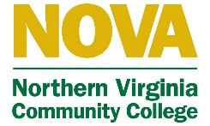
Northern Virginia Area Health Education Center
Internship application
First name:______________________ Last name:_______________________ M.I.:_______
Date:__________________ Email address:_______________________________________
Address:____________________________ City/State:________________ ZIP:___________
Phone:_____________________________ How did you hear about us?:_________________
College/University:____________________________ Major:_________________________ Minor:_________________ GPA:___________ Expected date of graduation:___________
Previous education/experience:
1.______________________________________________ Year completed:______________
2.______________________________________________ Year completed:______________
3.______________________________________________ Year completed:______________

Why are you interested in interning at NVAHEC and what do you hope to get out of this internship?

What are your top three strengths and weaknesses?

How experienced are you with Microsoft programs and design software?

Do you have any experience in topics such as research and grant writing?

How willing are you to work with a diverse group of people?

What is your availability during the week? List all times you are free.
Monday:_____________________ Tuesday:_____________________ Wednesday:__________________ Thursday:____________________ Friday:______________________

Reminder: Please attach a copy of your resume and a cover letter before submission. Please contact Dr. Rebecca Vargas-Jackson, Executive Director. Email: nvahec@gmu.edu with name, major, resume, and cover letter.

